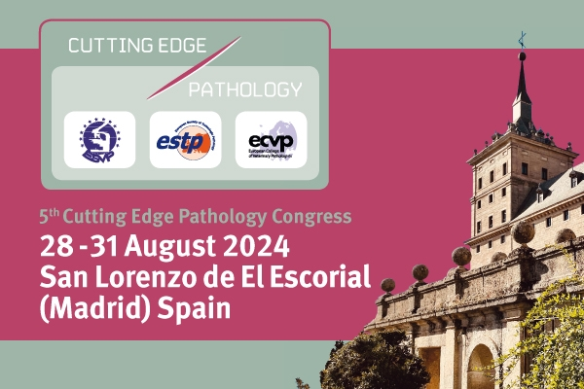

REGISTER NOW!
Registration is now open for the 5th Cutting Edge Pathology Congress! The congress will be held at Real Centro Universitario Maria Cristina from August 28th - 31th 2024 in San Lorenzo de El Escorial (Madrid), Spain.
For the first time, 5th Cutting Edge Pathology Congress will be held in San Lorenzo de El Escorial, the mountainous northern satellite town close to Madrid at the Real Centro Universitario Maria Cristina from 28th to 31st August 2024. The venue of the congress is part of the historic monastery declared a UNESCO World Heritage Site and location of the summer courses of the University Complutense of Madrid.

REGISTER HERE
Program
There will be plenary lectures, oral presentations of original scientific work, interactive case presentations, and poster session. In addition to interesting ESVP/ECVP/ESTP Joint Plenary Lectures, the ESVP/ECVP part of the congress will offer a wide range of updated veterinary pathology topic sessions, covering diseases in both domestic and non-domestic animals. Engaging interactive workshops and educational sessions will be held, along with poster presentations and oral communications. Please visit the website for the full congress program.
Book your hotel room as soon as possible!
San Lorenzo de El Escorial is a picturesque village just outside of Madrid. Make sure to book your hotel room in a timely matter via Revolugo, the official hotel partner for the CEP Congress. They offer a wide choice of accommodation at specially negotiated rates. Please go to the website to get more information and book your own room accordingly!
Call for Mystery Slide Session
The ESVP/ECVP Scientific Committee is preparing an interactive “Mystery Slide session” where each case will be presented and informally discussed with colleagues in 10 minutes. The topic of the session is open. The case session will be held on Saturday, 31st August 2024. For more information about submissions for the Mystery slide session click here.
Abstract submission
The abstract module is open and you can submit your abstract now!
Click here for more information about abstract submission!
Abstracts can be submitted until 30 April 2024, 23.59 GMT +1
More information about the congress and to book your hotel please visit the congress website!

