EMOTIONS AS EXPERIENCE OF INFORMATION FLOW
Konstantin Lidin

Emotions play a very significant role in all areas related to the human factor [1]. The problem, however, is that the existing theories of emotion seem to fit only within their own narrow field. Attempts to use each of the theories in other areas are sharply criticized [2, 3].
Our idea is to define emotions as the experience of information flow characteristics. In turn, we understand information as a structural aspect of the existence of matter, along with the inertial aspect (substance) and the dynamic aspect (energy). We believe that information is no less material than matter and energy.
Consider the flow of information through the human senses. Like any flow, this flow can be strong (intense, with a lot of information per unit time) or weak. It can also be ordered (laminar) or chaotic (turbulent).
The high intensity of the flow corresponds to the emotions of the group "interest, enthusiasm, excitement". Low - to the emotions of the "sadness, despondency" group. The laminar flow of information corresponds to the emotions of the "conscience, guilt" group. Turbulent - "fear, anxiety."
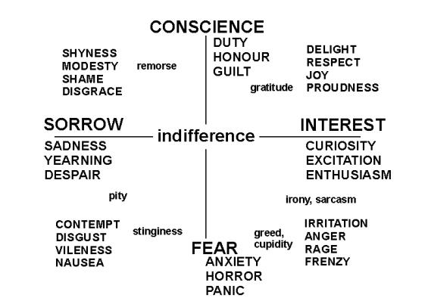

Axes "intensity" and "order" are orthogonal to each other and form the basis of the Cartesian two-dimensional space. Thus, we get a "space of emotions", in which everyone points to a certain emotion. For example, the diagonal vector between the "interest" and "fear" semiaxes corresponds to the emotions of the "anger, aggression" group, and the vector between the "fear" and "sadness" semiaxes corresponds to the emotions of the "anger, aggression" group. groups "disgust, contempt". Diagonally between the vectors "sadness" and "conscience, guilt" are the emotions of the group "shame", and between "conscience" and "interest" - the group of emotions "joy, pride".
Of course, only a few areas of the emotional space have their own names in any language. Most of the emotions are either "nameless" or indicated allegorically, with the help of comparisons and metaphors.
The center of the space of emotions is the state of indifference. In ancient Greek philosophy, this state was designated as "ataraxia", in Sanskrit it corresponds to the term "ahimsa", and in Chinese philosophy - the principle of "wu-wei".
The farther from the center, the more intense the emotions. For example, a weak form of the emotion "anger" is called "displeasure, irritation", and an extremely strong emotion from this group is called "rage, fury".
The emotions of the left half-plane around the “sadness” half-axis slow down the processes in the body (they act asthenic). When experiencing sadness, breathing and pulse become slower and smaller, metabolism and energy production are inhibited at the cellular level, and so on. Unlimited growth of such processes can also become incompatible with life. In the same way, other groups of emotions have their own physiological limits on intensity.
The bodily aspect of experiencing emotions allows you to associate them with the qualities of the images that a person perceives. The nervous system, and after it, the whole body is tuned to experience the information flow with certain parameters by changing the balance of neurotransmitters. For example, an increase in the concentration of dopamine and serotonin brings the nervous system into a state that is most effective for experiencing intense flows of information; adrenaline helps to experience chaotic flows of information, and so on.
Sthenic emotions, having a stimulating effect on the body, contribute to an increase in visual acuity, especially color (since the cones in the retina are more mobile in their states than the rods). Other perceptions are heightened as well. As a result, a person in a sthenic state perceives the world as brighter, more colorful, dynamic, loud and resonant, saturated with intense smells and tastes.
Accordingly, the emotions of the sthenic group (“interest” and those close to it) can be stimulated with the help of “hot” images with high brightness, colorfulness and dynamism. Voiced and loud sounds, intense smells and tastes, etc. are perceived as more interesting.
On the contrary, the emotions of the asthenic group (“sadness” and around it) are stimulated by the perception of “cold” images - static, dull and gray. The "sounds of sadness" are quiet and muffled, the tastes and smells are faint and nuanced.
Images corresponding to the emotions of the upper half-plane (“conscience, guilt” and those close to them) are distinguished by orderliness and harmony. In terms of visual mode, they rely on classic color chords, clear symmetry and balance. Their sound is rhythmic and harmonious. In the olfactory sense, natural combinations of taste and smell are used.
The lower half-plane of the space of emotions corresponds to emotions of a chaotic type (“fear”, “anger”, “disgust” and those close to them). Such states correspond to colorful, disharmonious, arrhythmic, dissymmetric and dissonant images.

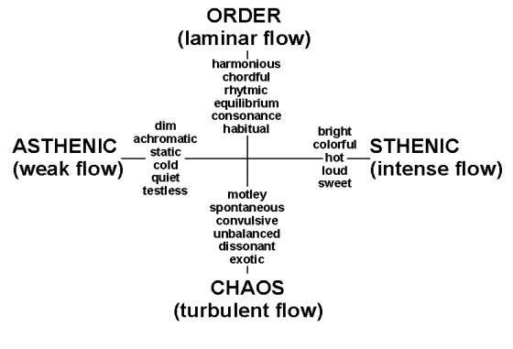
The interpretation of emotions as parameters of the information flow makes it possible to build quantitative models for the analysis and synthesis of images in various fields. Our experience has shown the applicability of the information model of emotions in various areas of psychology, urban studies, architecture and design, economics, management, pedagogy, cultural studies, journalism, literary criticism, and so on [4]. We are currently working on using the information model of emotions in the field of human-computer interaction (artificial intelligence).

References
1. Emotion-oriented Systems (2011). Catherine Pelachaud (Ed.), London : Wiley
2. Scarantino, Andrea and Ronald de Sousa, “Emotion”, The Stanford Encyclopedia of Philosophy (Winter 2018 Edition), Edward N. Zalta (ed.)
3. Handbook of emotions (2008). Michael Lewis, Jeanette M. Halivand-Jones and Lisa Feldman Barrett (Ed.).3-d edition. NY – London : The Guilford Press
4. Lidin K. et all (2017) Applying the theory of informational ﬂows in urbanism for a practical experiment in architecture and land use. Revista Espacios, V. 39(1), 12-21

