Table 1. The visible and Invisible Worlds in Flesh ontology of Merleau-Ponty and in the complementarism proposed by Sungchul Ji (1937- ) in 1995 [1]. According to Douglas Sayer Ji [2], the Flesh ontology and complementarism are closely related.
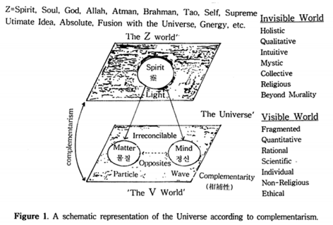 | 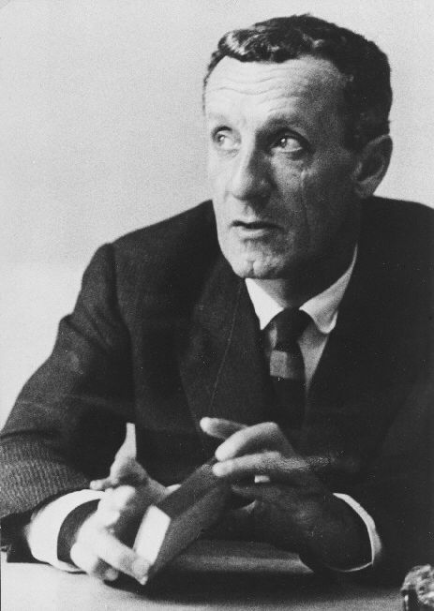  Maurice Merleau-Ponty  (1908-1961)
[1] Ji, S. (1995). Complementarism: A Biology-Based Philosophical Framework to Integrate Western Science and Eo, astern Ta in Psychotherapy East and West: Integration of Psychotherapies, Korean Academy of Psychotherapists, 178-23 Sungbuk-dong, Songbuk-ku, Seoul 136-020, Korea, pp. 517-548. PDF at http://www.conformon.net/wp content/uploads/2012/05/Complementarism_ 1995_ Proceedings2.
[2] Ji, S. D. (1996). Two Philosophers of the Flesh. In S. Ji (2018). The Cell Language Theory: Connecting Mind and matter. World Scientific Publishing, New Jersey. Appendix I.

