Dear Stanley, Joseph, Pedro and All,
Let me connect with my final mail of April “Chuan’s reply16”. First echo with Stanley’s echo.
Yes, dear Stan, your memory of Great Depression let me think of an ancient ballad in Yun Nan Province, China.
Same Sense
Can the Sun have a rest? It should rest;
Can the Moon have a rest? It should rest,
Can women have a rest? She can not rest
Otherwise the fireplace should turn off

If women rest,
the center-fireplace should turn off.
太阳歇歇么歇得呢，
月亮歇歇么歇得呢，
女人歇歇么歇不得。女人歇下来么
——火塘会熄掉呢。
You see how similar with the lines you mentioned?

Man works from sun to sun
But women's work is never done!

The women in American of Great Depression, women in Chinese ancient villages, and woman in FIS in Internet are same, with same sense.
In fact our “Frontiers of Intelligence Science” discussion session still has many items should go on to do summary.
After echo to dear Stan’s movable poem, let me talk about the frontier work Chuan and her students are doing – it is the first question dear Joseph emphasized in the beginning of our discussion. Please forgive me for reply late.
Yes, language always should be the key of intelligence study.

Chen Yin Ke Puzzle
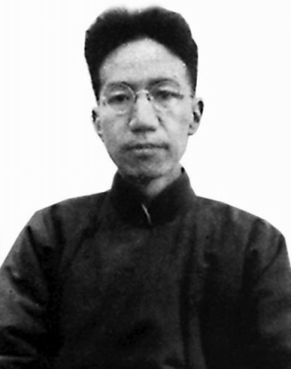
Chen Yin-ke was a famous historian and linguistician. He wrote a letter to Liu Shu-ya, the director of literature department of Tsing Hua. In the letter he explained why he has given an item of do couplet in the entrance examination and the value of couplet in Chinese and finally pointed out that the special grammar of Chinese has not created yet, at 1932. I call that Chinese grammar has not exist and how to set it what he pointed out as Chen Yin Ke Puzzle.
I use a scientific saying to “couple”. The “antithesis” in English, and paradox in Indian, especially in Getanjiali. Yes, in the world wide view we can find languages as the manner and fruit of intelligence there are some universal/ general structures.
83 years has pasted, few scholars really pay enough attention to Chen Yin Ke Puzzle.
Who can help me study Cicero’s “Couple”? busy, and not easy the back to such so interesting and important study.
The Symmetry and Topology structure in Chinese and in other language world wide. Couplet emphasize is one of the of the symmetry of language phenomena. For example in English there is Antithesis - the rhetorical contrast of ideas by means of parallel arrangements of words, clauses or sentences）for example: They promised freedom and provided slavery.
More later.
Dear Joseph you new mail let me think more and know that should be a heavy task, and decide to sent this mail lasted so long to FIS first. I should try to connect these questions to our explore in Chinese. You know the language Chinese, is the key to know orient thought.

A new term should begin in Chinese universities.

Best wishes,

Chuan
2015-04-20 to 2015-08-30

