Dear Rafael, Pedro, Joseph and ALL,

Dear Rafael I have read the articles you mentioned. There are many echoes, here focus to two points, more next mail.
Yes, “To be aware of this tension without subordinating one another is not an easy task.”, this let me think of a interesting and useful saying in fairy tale:

“the different branches of arithmetic are --- careerism perplexed, uglify, mock”
Lewis Carroll “Alice’s Adventures in Wonderland “
(I translate it from Chinese fairy tale book. you can give the original words.)
I say it is useful because it is used every year while I begin my course of combinatorial mathematics, I should mention such a saying and draw such a picture, to let students gain a sense with mathematics from a special way. From their silence I am sure it is really useful though I can not describe well. Yes, the way of mathematics/ poetry/new science is not easy the same. Our mind has many different directions, Lewis looked out. He is a nice intelligence scientist. We have so many leaguers!
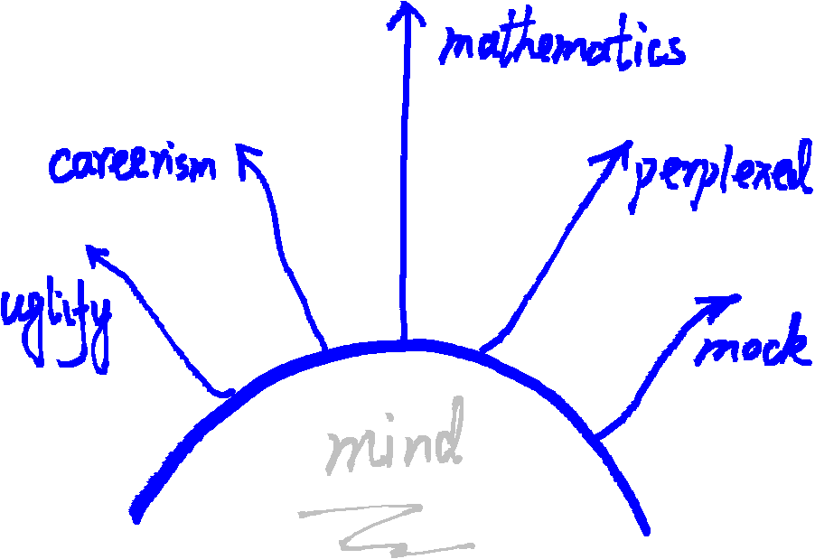
As the words in your thesis “THE DAO OF THE INFORMATION SOCIETY IN CHINA”: Direct and indirect speech in the "Far West" and “Far East”.
Dear Joseph I think we are all waiting for your voice.
Dear Pedro you see our discussion is so nice!

Another interesting news: how MIT celebrate the Pi Day -
http://www.boston.com/news/local/massachusetts/2015/03/13/mit-admissions-decisions-will-come-the-eighth-digit/DPjQqBQubhIXh9pmgX6flM/story.ht

best wishes,
Chuan
March 24, 2015

