Dear FISers,
I studied theoretical physics and my academic dissertation was on EPR Paradox. Today I drew a picture of EPR to show my feeling with two IS.
You know EPR (Einstein-Podolsky-Rosen) paradox. Refer to this I learn that Intelligence Science belongs to the right side with eye. In fact, in the view of science, we ignore our own in the process of observation. So Intelligence Science is back to the backstage that our recognize should be whole. Equally, as for orient thought pay attention to the said with eye - this is its stage, that the said with atom/solar system is its backstage. Now it is time to integrate and balance both side.
Through experimental apparatus observers observe object that is a scientific study model we are familiar with. Let us look at it longer and we can find our attention focus in the stage too much and ignore ourselves/brain too much. We should take back some of our attention to observer itself, that we can gain more and should deal with many thing, From matter to mind is a great step. Now from atom to bit, AI is a half step, go ahead, “form AI to IS (both IS)” is the next half step. Then we approach the center of questions.
more latter. Discussion are welcome. Thanks!

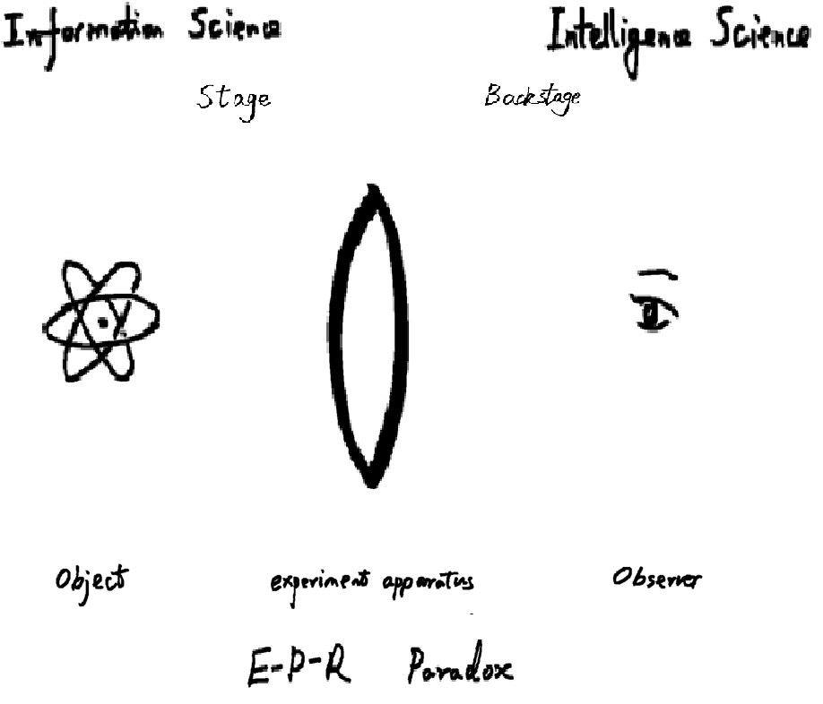

Best wishes,
Chuan
March 10-11, 2015

