Three Symmetry dimensions in the World Civilization Should Be Balanced
--- What is the cover of the new book Saying?

Dear FISers,
Zhao Chuan’s new book “the Frontiers of Intelligence Science” is published at November, 2014.
This is the whole cover with cover and back cover and flap, the Science Press who publishes this book sent to me. The cover is one of my paint. This pain is not special drawn for this book. In fact it existed in my mind near two years and finished at May, 2013. I think I am abstract my own mind naturally, topologically. The alcohol lamp, especially the fire and the Chinese writing brush, especial the brush appeared in mind independently early or late, and I have not put them together and have not time to finish it as a paint that first I drew a writing brush down first. Till one day I put the two symbols together as a whole paint.
While I need a cover for the new book, I thought of this small paint. I designed the preliminary cover and the connected editor finished it and added a halo up the fire.
These two years, my group has been studying symmetry. We especially look symmetry as a manner of cognitive approach and focus the symmetry of language. You know there are so many linguistic symmetry phenomena in Chinese. This is a breakthrough in our Natural Language Understanding study. The student are all study computer science, they are not enough know symmetry and Chinese and symmetry in Chinese, though it is their mother language. I always use this paint as an intuitional example to show them symmetry or say how to analyses the complexity of symmetry in a thing. I told them: “at least there are three dimensions in this picture: if the alcohol lamp means science and the writing brush means orient thought, that is the symmetry of west and east; and it can means science/technology and art/sinology; matter and mind, and so on.” Is this process a natural computation?
Now while in our FIS forum, Pedro put me out as a chair for the seminar “the Frontiers of Intelligence Science”. He has put the preface of the new book in the seminar. So I should go on explain more for this issue. I think of talk about the new book’s cover. For it is in image not in any language and we all can understand image at once. Then this paint has a new mission, to show the main idea of my book and point out the task of now world civilization for my FISer leagues. Just as the three dimensions mentioned up, West and East, Science and Art, matter and Mind. The first one “West and East” is so great, and the second “Science and Art” is so delicate, the third just the hard core of philosophy.
Yes, all are hard. But now or say just now with intelligence science we straightly approach them. Let us try to talk about such big questions those we have to face as thinkers. These questions can not be dealt with well, if we are alone, we are just experts in some narrow fields. We should fusion our attention and focus our intelligence, that we can burden them and can create new civilization.
You know Prof. Pedro suggestion me translate the preface to English for a session at 22,Dec. 2014. Till now two months and a half has pasted, during these days with respectful Doc. Joseph Brenner we exchange many mail to prepare for this session. After I translated my preface first, Joseph rewrote it send back, I rewrote and send back to him, some Chinese express we have to give up. Then we gained the text as FINAL7. He has visited my university and writen the preface for my book. And before use it as a “kickoff file” (Pedro’s interesting saying), Pedro has rewrote the same, and we exchange some mails for details the same. In fact, beside these, we have prepared many other important materials; in my side, in China for the new book we have had two seminars about Intelligence science. So there are so many things we should share.
My editor asked me gave a subtitle for the book, I gave it as “Something is possible” and now it should be “Something is beginning”.
Let begin our, of course wonderful and exciting discuss! Let us approach the new information of science from China.
Beat regard and thanks to Joseph and Pedro, you bring this discussion as farther opportunity and growth to Intelligence Science.
Best wish to our intelligence time, yes, it is the wonderful time to think think itself to think the big structure of our civilization.
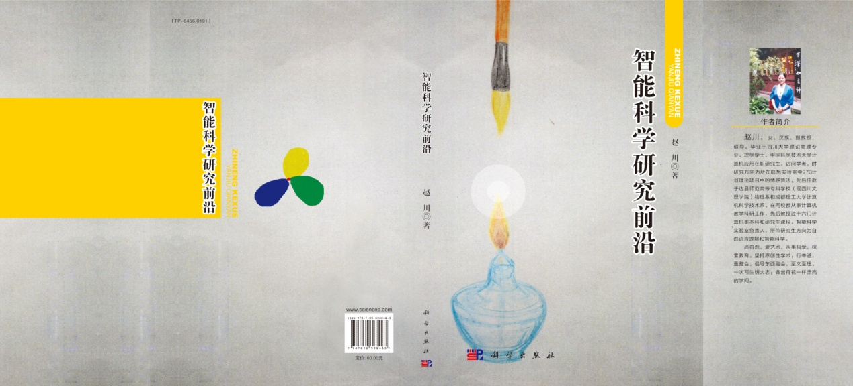
Cheers
Chuan
2015-3-4

